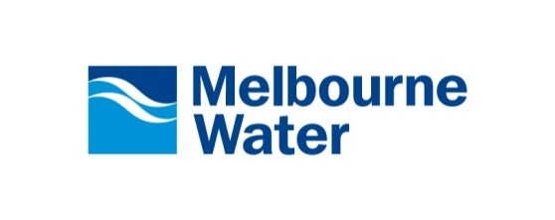
Consultant’s Design Certification Statement
File reference:  Job description: | _______________________________________ .
Municipality: | _______________________________________ .
Developer: | ______________________________________ .
Consultant: | _______________________________________ .
Nominated Rep.: | _______________________________________ .
Consultant Ref.: | _______________________________________ .
Melbourne Water Ref.: | _______________________________________ .
As the Consultant's nominated representative responsible for the design of the Works I certify that:
- the design is in accordance with the Conditions of Agreement,
- the design has been completed in accordance with our company's Quality Management System (ISO 9001),
- the design is in accordance with section 5.0 of the Land Development Manual - Drainage Design and Construction Guidelines and Requirements,
- the design of the Works is in accordance with Melbourne Water Guidelines and drawings,
- the design is in accordance with all relevant Melbourne Water Specifications and relevant Australian Standards,
- the source documents have been filed in a manner that can be readily accessed for audit purposes,
________________________________ | ________________________________
Name  (Responsible Design Representative) | Signature
________/________/________ | ________________________________
Date | Company Position
________________________________ | ________________________________
Name  (Nominated Representative) | Signature
________/________/________ | ________________________________
Date | Company Position

